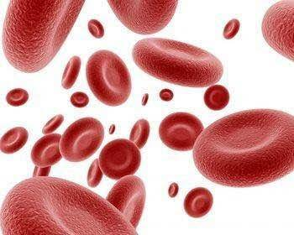 The Sickle Cell Association of BC
Membership Application Form
Thank you for your interest in becoming a member of the Sickle Cell Association of BC (SCBC). Please complete the form below and return it to The Sickle Cell Association of BC, 322-104-1015 Columbia Street, New Westminster, BC, V3M 6V3. Phone: 778-710-0024. Or visit us at our website at www.sicklecellassociationofBC.com. Please feel free to attach additional sheets to answer questions as necessary.
New Membership _____ Renewal _____ Date: ________________________

Member’s Information

First Name Last Name
| | | | | | | | | | | | | | | | | | | | | | | | | | | | | | | | | | | | | | | | | | | | | | | | | | | | | | | | | |

Mailing Address Suite or Apt Number
| | | | | | | | | | | | | | | | | | | | | | | | | | | | | | | | | | | | | | | | | | | | | | | | | | | | | | | | | |

City Province Postal Code
| | | | | | | | | | | | | | | | | | | | | | | | | | | | | | | | | | | | | | | | | | | | | | | | | | | | | | | | | |

Phone / Cell ______________________ E-mail Address / Website ___________________

I am a…
□ Patient □Caregiver □Family Member □Parent of a child with Sickle Cell
□Medical Professional__________________(please specify) □Other_____________________ (please specify)
All personal information collected by the Sickle Cell Association of BC (SCBC) is used solely as a means of communication with its members and those interested in becoming members. We gather and store information in a secure database and use it only to communicate with these individuals. We do not sell or share this information in any way with third parties.

Member Fees and Contributions:
I would like to become a member, enclosed is my annual dues contribution
□$20.00 Individual □$40.00 Family Membership □ Number of person with sickle cell in family
□I would like to make an additional contribution of $_________________
(Your donation will be applied to any of the following areas of SCBC programming, which include, but are not limited to: educational materials, administrative costs, awareness campaigns, patient scholarships, local support groups/regional chapter support and educational events such as conferences.)

Volunteer Interest:
□I am interested in volunteering my time to SCBC. I would like a member of SCBC staff to contact me to explore ways in which I can help.
Payment:
□Visa □Mastercard □Cheque or Money Order enclosed (Made payable to the Sickle Cell Association of BC)
Total enclosed $__________________________ Signature_______________________________________________

Card Number | | | | | | | | | | | | | | | | | | | | | | | | | | | | | | Expiration date| | | | | | | | |

Name (as it appears on card) | | | | | | | | | | | | | | | | | | | | | | | | | | | | | | | | | | | | | | | | | | | | | |

